1. Creating computer engine google

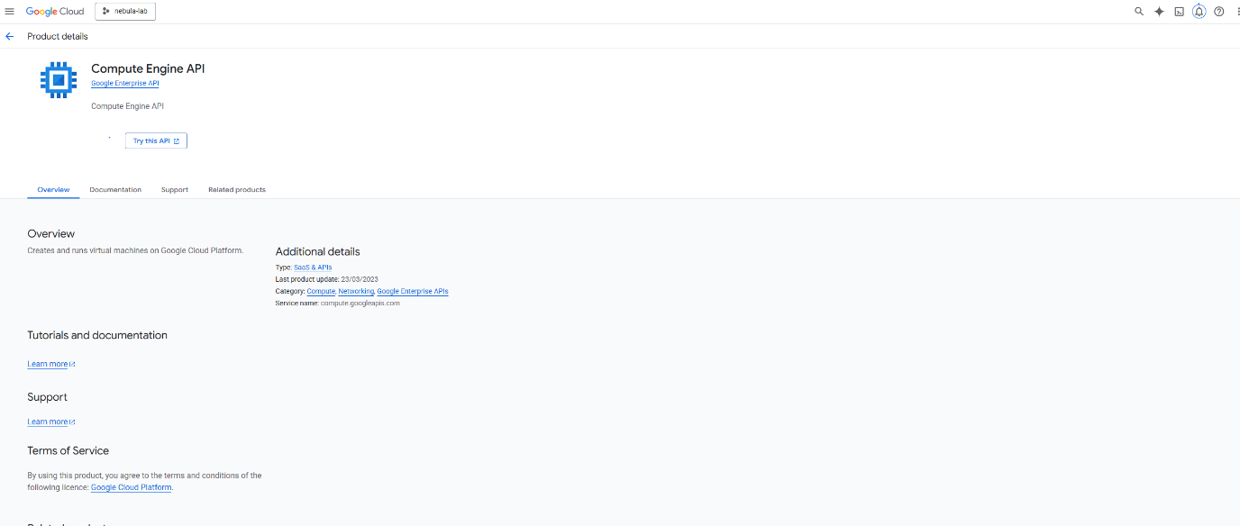

1. VM created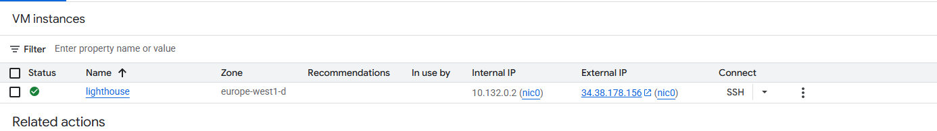
2. Installing nebula on vm 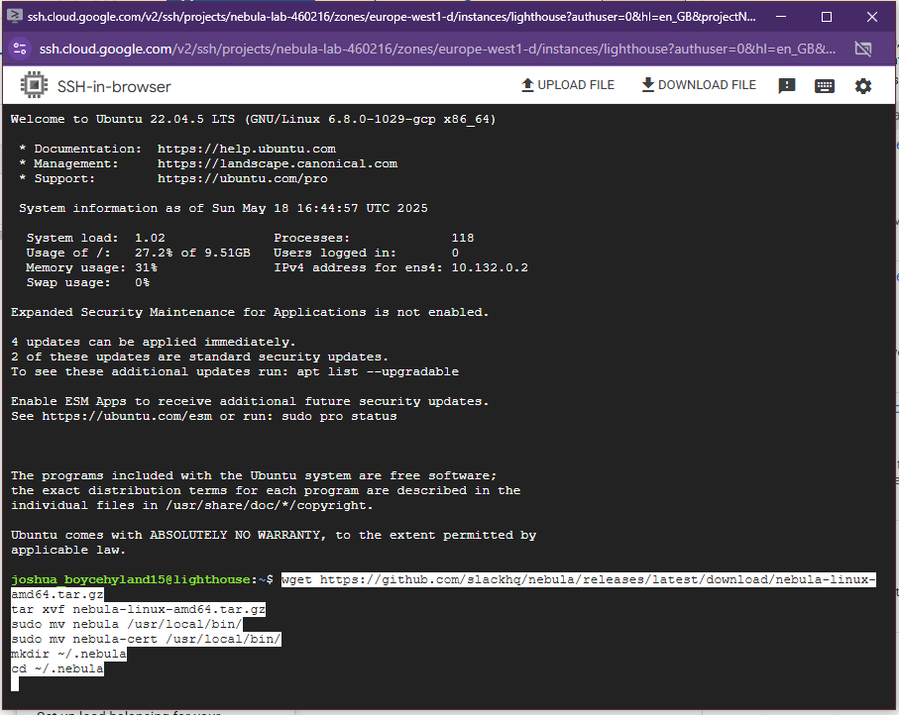
3. Installe dnebula an dcreated certs

